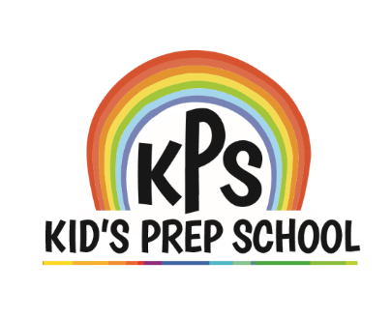

KPS NEWS

[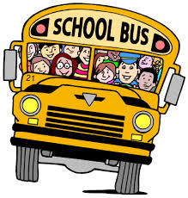](http://www.google.co.uk/imgres?imgurl=http://www.marion.k12.fl.us/dept/ssp/extra/image/schoolbus.gif&imgrefurl=http://www.marion.k12.fl.us/dept/ssp/trn/&h=421&w=402&tbnid=4Jze05wvZG_HDM:&docid=_OpPI7U3ihuN5M&hl=en&ei=0e-3VfVK5oLtBo66g5AI&tbm=isch&ved=0CFcQMygYMBhqFQoTCLX3u7je_sYCFWZB2wodDt0Agg)

**Nationally Accredited**

AUGUST 2024

|  |
| --- |
| REMINDER |
| **VPK Orientation**  **Tuesday, August 6th**  **6:00 PM** |
| **Back to School**  **Sales Tax Holiday**  **July 29th - August 11th** |
| **VPK Begins and**  **FIRST DAY OF PUBLIC SCHOOL**  **Monday, August 12th**  **For every child you refer to our school, you will get a free week of tuition!** |

**Dear Families:**

We are excited as our new school year begins on August 12th. A new beginning brings opportunities for us to meet new friends and share our experiences. That is exactly what our curriculum guides us to do this month. Our curriculum theme will encourage us to share information about our lives, which will enhance children’s self-concept, improve language development, and build friendships at school.

Please become familiar with our reception area, where you will find school information as well as community resources. You will also find our menu posted, which changes weekly. Talking of food, read below for some lunch box ideas for school age children!

Our door is always open to you so that we can communicate our concerns, compliments and ideas for change.

Remember to check our website that we are continuing to build:

[www.kpschildcare.com](http://www.kpschildcare.com) and like us on Facebook!

Have a safe and memorable new school year.

The Administration Team

**TEACHABLE MOMENTS**

**“THE LUNCH BOX”**

**Appealing Lunches:**

Children look forward to school lunches that have been planned especially for them. Appeal to your child’s taste buds and appetite by keeping foods simple, adding contrast and variety, and preparing small serving sizes.

**Something Special:**

Children enjoy an occasional surprise in their lunches. Consider adding a non-food item that says, “You are special!” Here are a few ideas for that special something:

* A picture of the family or a pet, a colorful or holiday napkin, a sticker.
* You can also choose a weekly educational theme and work it into lunch during the week. Theme ideas could include a letter, number, color, shape, word, or even a scent!

**Did You Know:**

* Toddlers and preschoolers grow more slowly than infants and usually are not as hungry as infants.
* Children’s appetites vary from day to day depending on their actual growth.
* Don’t worry if your child occasionally doesn’t eat a meal. It is important that children eat a balanced diet over a 3 to 4 day period.